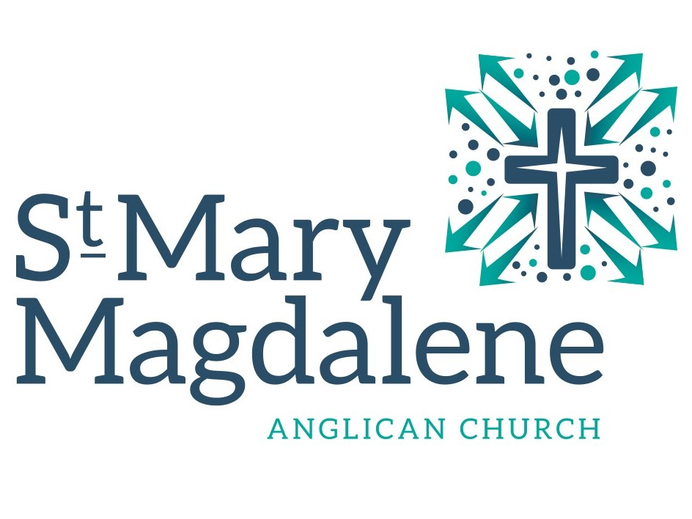
News for Scattered Pews
Summer 2022

Val’s Voice
These summer days, these days when so many are travelling, it seems like with every day there is news of
violence in a way that seems different than it has been.
Some of the folks from Pakistan wait for friends or relatives fleeing as refugees; some of our
Nigerian siblings fear for their family members back home, as Nigeria has its own violence… and life is a struggle for many on this land as well.
But still, the world is beautiful. There is much
to celebrate. And God in Christ is faithful. Just last night, Paul and I decided (rather randomly)
to watch a film about the drummers of 10 or 12 bands, their paths to fame, and the way these women and men realized when they were tiny
little kids that drumming was something they
absolutely loved.
We talk to people from time to time who feel
the same way about cooking. There are others who find joy in hearing peoples’ stories of their lives, or caring for little kids in early childhood education facilities, or caring for elders who
need some assistance.
There is plenty that is broken in our world, but there is so much that is so good, ways that
each of us enrich the lives of those around us with laughter or a kind word, or a passionately spoken speech to offer strength to our world
that is wavering…
Creator: Fred Froese | Credit: Getty Images

What are the things that give you life these days? What things gave you life in days that are gone? These joy-filled experiences present in our lives now and in times past that we remember are
all gifts of God… They are also gifts that you
can share with those around you. This summer, take some time, and consider where your joy or passion is found and how you can pass it on…
Below are the Prayer over the Gifts and the Prayer after Communion for the upcoming Sunday. As these particular prayers in the liturgy always do, they help us see all of our lives as an offering to each other and to God. I invite you to pray them over a few times, during these next days (and then move on to the prayers for next week, in the liturgy). Think about your own gifts and your own loves… and as you do so, offer those gifts given by God back to God.
Blessings to all of you, these days of summer…
Val

Living God, accept all we offer you this day,
and grant that we may find
the presence of your Son
in the Church, in each other,
and in all who struggle in the world,
for whom he gave his life,
Jesus Christ your Son our Lord.

God of truth,
we have seen with our eyes
and touched with our hands the bread of life.
Strengthen our faith
that we may grow in love
for you and for each other;
through Jesus Christ the risen Lord.

Vestry Notes from June 28
Church finances are following our budget fairly closely; it is good to recognize, of course, that
our budget was a deficit budget. Thanks to all of you who so faithfully keep up with your offering. Quite a few people caught up on envelope giving in April and May: perhaps meeting in the church has made it a bit easier. It was noted though
that offering has started to slip again a bit, with summer upon us.
Corporation and a faithful group of people
worshipping on Zoom have been chipping away
at the technical challenges of hybrid worship to make our in-person services available online.
Progress is being made; there are challenges,
but we are getting there. Thanks to Chima,
Darryl, Cherryl and all those who have offered their time to assist!
A few months ago our City Councillor, Brian Mayes, kindly offered a grant for the church to complete some small project. After some
reflection at Vestry, in consultation with our property chair, Brian Crow, it was decided to
use the grant to commission a young artist to
update the bus bench on the front lawn of the church. And so Annie Beach has begun her
planning and is hoping to complete the project sometime this summer.
The Worship committee noted that this week it
is 21 years since the Waterloo Declaration was passed by the Anglican Church of Canada and the ELCIC – the Full Communion Agreement between our two church bodies. In celebration, we will send flowers to former Primate Michael Peers, in thanks for his part as architect of this agreement.
Wearing of masks:
Vestry decided to relax the requirement for use
of masks in the church. After a good discussion,
it was agreed that given the removal of all mask requirements provincially and federally, and a general decrease in masking in public, it seems like time to modify our COVID rules.
Therefore, we no longer require that masks be
worn either by our members for events of our church, or by community users of our building. Anyone is welcome to wear a mask for these events, and other groups are welcome to have their own guidelines, but it will no longer be required by our Vestry. The situation will be monitored, and changes may be made in the future if they seem beneficial.
Vestry is not suggesting with this change that
it feels COVID is over. On the contrary, we expect it will remain a threat for some time yet. We encourage all participants to be fully vaccinated and boosted as this remains a strong defence against serious illness and hospitalization. We also know that for those who may be more vulnerable or in regular contact with other vulnerable people, masking is an additional level of protection. We encourage you to be take these needs into account as you decide.
We also know that people have different comfort levels regarding wearing or not wearing a mask.
If you are unmasked, we suggest you check with people wearing masks if they are okay with you sitting by them. After all, it is good for us to be sensitive to the needs and wishes of others!
Thanks for your assistance in caring for the vulnerable among and around us - we all need
the care and support of those around us!

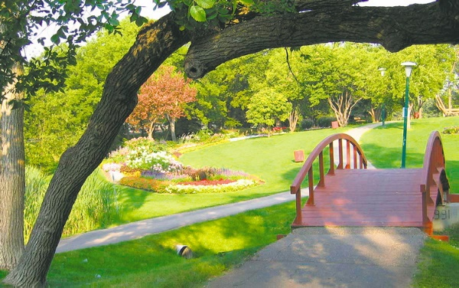

In the park or on the water, or wherever you are happiest, have a safe and blessed Winnipeg summer!

From the Worship Committee
We have resumed using wine for the Eucharist, and it is a relief to have our feast feel more
complete.
Bishop Geoff has noted that an epidemiologist
has clarified that using the common cup is safe
at this time in COVID. That being said, as he is aware of the anxiety of some, Bishop Geoff has also given permission for parishes to use both
the common cup and individual glasses, to ensure that all feel safe as they receive Eucharist. This new procedure is going very smoothly.
At our last worship committee meeting, we had
a discussion looking more closely at some of the familiar words of the liturgy; important, as there is ecumenical consensus on a number of possible variations.
There was a request that in the “Holy, holy” for
a season we sing “Blessed is the One who comes in the name of the Lord” rather than “Blessed is he…” This means that as we celebrate Jesus,
who comes in the name of the Lord, we can also be aware that we, ourselves also come in God’s name, and that we are blessed when we do so!
There was also a request that in the “Lamb of God” sung just before we receive Eucharist, we use the approved alternate text “You take away the sin of the world” (rather than sins…) The change in word draws attention to the fact
that it is our entire world that is broken – sin is present in systems, and history, not just in our own individual actions. As we sing about Christ taking away the sin of the world, then, we lift
up these broken systems seeking God’s healing.
Bishop Geoff has approved both these changes that can add greater richness to our experience
of the liturgy.

The Parish of St. Mary Magdalene is on Treaty 1 territory.
3 St. Vital Road, Winnipeg MB R2M 1Z2
stmarymagdalenewpg.org
Phone: 204-253-0555 (church office) 204-930-7253 (Val’s cell)
Email: stmary@mymts.net

In other news…
We are coming up again to the Feast Day of our namesake; we will celebrate St. Mary Magdalene Day on Sunday, July 24 with games and a feast in her honour. Carey and Caroline seem to be facing off for organizing! Carey is looking for people to sign up to bring salads and planning to barbecue hot dogs and hamburgers, while Caroline is looking after games, and has declared that this year as well as the usual fare, she will make sure
there is BBQ chicken for our celebratory meal. Come and join in – sounds like it will be fun!
Over the course of the pandemic, the size of the Altar Guild has decreased from 12 to 4, as people have decided it is time to conclude their work. Some folks say “Once you are on the Altar Guild
it is like a life sentence!” Really, though, it is
just a series of tasks that need to be completed for us to worship as community. There are those
who love the work, like Darryl who says the time spent setting up the altar for Eucharist is like a short time of retreat. I (Val) have a number of times taken the linens home to wash and iron, and I enjoy the small amount of time it takes
to iron 2 or 3 squares. It is fun to start with
rumpled damp linen, and end with pristine cloths, again ready for use; it’s satisfying… a clear
accomplishment of a task! If you are interested, please speak to Val or Darryl. The work isn’t so daunting! And we would be happy to fill you in
on what is needed.
Vestry is planning a Parish Visioning Conference
for Saturday, September 24. We will have a special guest in Deacon Michelle Collins, Assistant to the Bishop of the Manitoba Northwestern Ontario Synod (MNO) of the ELCIC to lead us through our reflections. It looks like the day will start at 10 am and wind up at about 3. Stay tuned for further information, as we look ahead to considering what our gifts and interests are in serving God and our neighbours.

