Onjisay Aki

"The Changing of the Earth"

Climate Change Initiatives Led by the First Peoples

Onjisay Aki
As the Original Peoples, we have lived here in our homeland for tens of thousands of years. Our earth is changing and so must we as people. Onjisay-Aki means “A changing earth” in the Anishinabe language, and it is also the name of a journey we are all on together. Our ancestors left a footprint, a trail founded on Indigenous values of respect, which can lead us all to have a healthy relationship with each other and the planet. Our children are depending on us to follow in those footsteps, walking this trail of peace, friendship and reconciliation

Turtle Lodge
The Turtle Lodge is founded upon spiritual, land-based teachings that bring balance to life. It has been built for our children ~ the center of our lives. Our fundamental goal is Mino-Pi-Mati-Si-Win – A Good and Peaceful Way of Life. The Turtle Lodge is based on the Seven Sacred Laws and the Eight Paths of Life, the ancient universal values of the Anishnabe People of Turtle Island (North America).

Indigenous Leadership
Our Elders have encouraged us to come forward to express our leadership, knowledge, connection to and stewardship of the land. Our knowledge has developed over thousands of years of living in close connection to our homelands. We want to share our wisdom, hear yours, and collaborate on a new narrative based on hope, peace and a belief that climate change is about human change – a change of heart.

Anishinabe Sacred Teachings
Mino-Pi-Matisi-Win
Mino-Pi-Matisi-Win is a belief system of the Original people of Turtle Island (North America). The words Mino-Pi-Matisi-Win mean “A Good Life” and we believe this good life is ensured by living the Spiritual Laws of the Great Mystery. This means living your identity, complete with your language, your customs, traditions, and following the Natural Laws of Nature.
Mino-Pi-Matisi-Win is about living from the heart – it’s about seeing, listening, feeling, speaking, and acting from the heart. This belief is at the center of the Onjisay Aki initiative, an oppurtunity for all peoples to come together heart-to-heart to illustrate our common vision.
At the foundation of Mino-Pi-Matisi-Win are the 7 Sacred Laws, represented by the seven animals.
The 7 Sacred Laws
The Seven Sacred Laws are represented by seven animals. Each animal offers a special gift and understanding of how we as people should live our lives on Mother Earth.

1st Teaching: RESPECT represented by the BUFFALO
The Buffalo stands on guard to remind us of the teaching of Respect. Respect all life on Mother Earth, respect Elders and people of all races. The essence of respect is to give and share. The buffalo embodies respect by giving of itself. The buffalo, through giving its life and sharing every part of its being, showed the deep respect it had for the people.
2nd Teaching: LOVE represented by the EAGLE
The Eagle welcomes all with the spirit of Love. The wings spread in welcome. Love is the essence of life. Always act in love. Love the Creator. Love Mother Earth. Love yourself, your family, and your fellow human beings.

3rd Teaching: COURAGE represented by the BEAR
The Bear stands tall to remind us of the teaching of Courage. Listen to your heart. It takes courage to do what is right.

4th Teaching: HONESTY represented by the SABÉ (BIGFOOT)
The Sabé holds its heart to remind us to live in honesty – to live from the heart. Never lie or gossip. Be honest with yourself and others. Speak from your heart. Be true to your word.

5th Teaching: WISDOM represented by the BEAVER
The Beaver brings the teaching of wisdom. Everyone has been given a special gift. Show wisdom by using your gift to build a peaceful world.

6th Teaching: HUMILITY Represented by the WOLFThe Wolf bows its head in humbleness as it brings us the teaching of humility, to show us all that we have been created equal in the eyes of the Creator. No one is greater or lesser in the human family. Think of others before yourself. Humble yourself to the Creator by being thankful.
7th Teaching: TRUTH Represented by the Turtle
The Turtle brings the teaching of Truth. Always seek Truth. Living the Truth is living all these teachings – Respect, Love, Courage, Honesty, Wisdom and Humility. Let us join together to help fulfill the prophecy of the Red people – coming together as a human family to bring truth into the world.

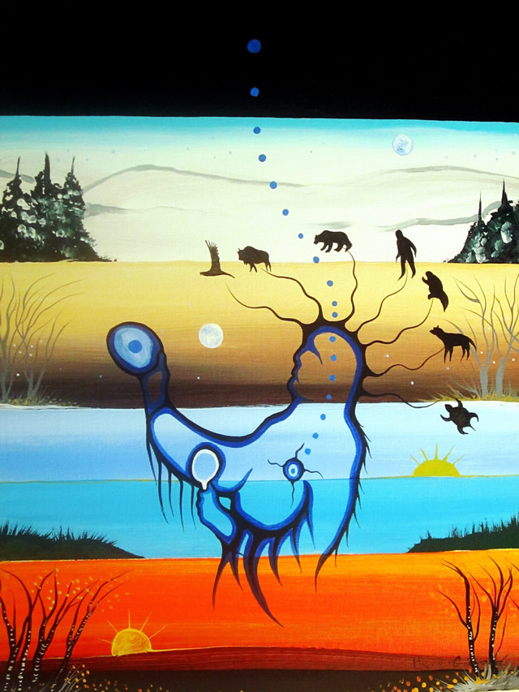

Share this
Copyright © 2019, Turtle Lodge

